**Assignment 8 - Practicing Pipes**

You learned a lot about Pipes - time to use that knowledge, use Pipes and even build your own Pipe!

The snapshot below explains the example app you're starting with and which tasks should be completed as part of this assignment.

Make sure to also answer why you implemented the solution you chose to use.

**Task 1** - Build a reverse pipe that basically reverses a string. (There is a reverse method in JavaScript that you can use but it only works on “real arrays”, not on string which technically is array of characters) (Hint: You would have to split the array by empty character first, then apply reverse and then join it together with empty character to get a string again)

**Task 2** – Build a sort pipe, which sorts this list by name of the instance, production user database and so on.

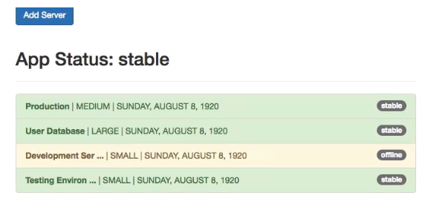

**Questions for this assignment**

**Please complete the tasks outlined in the instructions above. Why did you choose the approach you took? Which problems did you encounter?**

**Download resource files**

* pipes-assignment-start.zip